**PROJECT STATUS**

|  |  |  |  |
| --- | --- | --- | --- |
| Project Name | Movie tickets online booking | Start Date | 10/08/2022 |

|  |  |  |  |  |  |
| --- | --- | --- | --- | --- | --- |
| Project Schedule | | | | | |
| No | Task | Start | End | Progress | Comments |
| 1 | Analysis, requirement | 10/09/2022 | 20/09/2022 | 100% | Complete |
| 2 | Design | 21/09/2022 | 01/10/2022 | 100% | Complete |
| 3 | Build phase 1 | 01/10/2022 | 15/10/2022 | 100% | Complete |
| 4 | Test phase 1 | 15/10/2022 | 20/10/2022 | 100% | Complete |
| 5 | Build phase 2 | 20/10/2022 | 20/11/2022 | 0% | Delayed |
| 6 | Test phase 2 | 20/11/2022 | 25/11/2022 | 0% | Delayed |
| 7 | Go live | 25/11/2022 | 26/11/2022 | 0% | Delayed |
| 8 | Document | 03/12/2022 | 07/12/2022 | 0% | Delayed |

**Task List:**

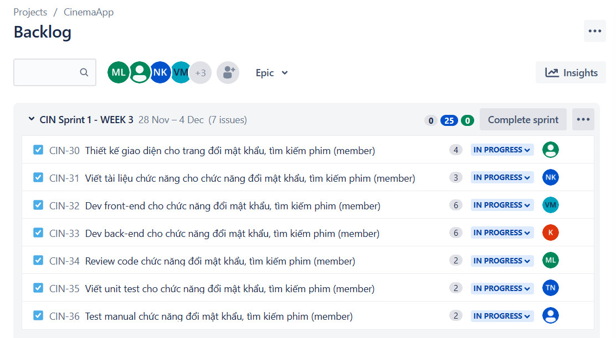

**Burndown chart**

